

**SCHOOL OF INFORMATICS & IT**

**Part 1: Project Proposal**

Student Name (Matric Number) :

Tutorial Group :

Jenny LING (TP)

Tutor :

Submission Date :

**Declaration of Originality**

I am the originator of this work and I have appropriately acknowledged all other original sources used as my references for this work.

I understand that Plagiarism is the act of taking and using the whole or any part of another person’s work, including work generated by AI, and presenting it as my own.

I understand that Plagiarism is an academic offence

and if I am found to have committed or abetted the offence of plagiarism in relation to this submitted work, disciplinary action will be enforced.

**Declaration on the use of Generative AI tools for assignments**

|  |
| --- |
| Describe how you have used Generative AI tools such as ChatGPT or Dall.E-2 in your assignment.  Show snapshots of the conversations with the AI tool (i.e., the prompts you used and the response you get from the AI tool). |
|  |
| How do you indicate the reference?  The content generated by AI tools are not retrievable except by the user who generated them, so they are considered non-recoverable sources. Although non-recoverable data or quotations in APA Style papers are usually cited as personal communications, with ChatGPT-generated text there is no person communicating. Quoting text from ChatGPT chat is therefore more like sharing the output of an algorithm, with a reference list entry and the corresponding in-text citation.  According to the official APA Style site, ChatGPT references should be cited as:  E.g. OpenAI. (2023). *ChatGPT* (Sep 25 version) [Large language model].  <https://chat.openai.com/chat> |

**Important Note:**

* Do not copy answers produced by the AI tool in totality as it is considered as plagiarism.
* Do not rely on any information produced by the AI tool blindly. You should always verify the answer with other sources. Do not assume that these answers provided by the AI tool are correct.

To achieve quality outputs from the AI tool, you should provide good prompt that is clear and

**Temasek Polytechnic School of Informatics & IT**

**Diploma in Information Technology**

**Cloud Application Development (CIT2C24)**

**Project Proposal**

|  |  |
| --- | --- |
| Practical Class: | PXX |
| Submitted by: (list all students) | <Name> / <Admin number> |
| Date: | dd / mmm / yyyy |

Table of Contents

Application Description 3

Microservices Architectural Design 4

Design Screenshot 5

Database Design Diagram 6

API Documentation 7

# Application Description

Write down the name of the application and describe the proposed functionalities

**List and describe the functionalities that your application will have. Note that you must have a minimum of 4 functionalities. Ensure that all HTTP methods are covered, that is, at least one GET, POST, PUT and DELETE function.**

Specify the target audiences of your application and how they interact with the application

**List the target audiences of your application and describe how these users interact with the application**

*(Visual aids such as use case diagram will be useful)*

# 

# Microservices Architectural Design

|  |
| --- |
| Draw your proposed microservices architecture diagram. |

**Using the microservices architecture diagram, indicate the AWS services that are used and illustrate how these loosely coupled microservices link to each other.**

Describe and support the reason for each microservice creation

**Include reasons for each microservices creation and share the reasons for the chosen AWS service in each microservices and for the overall architecture design**

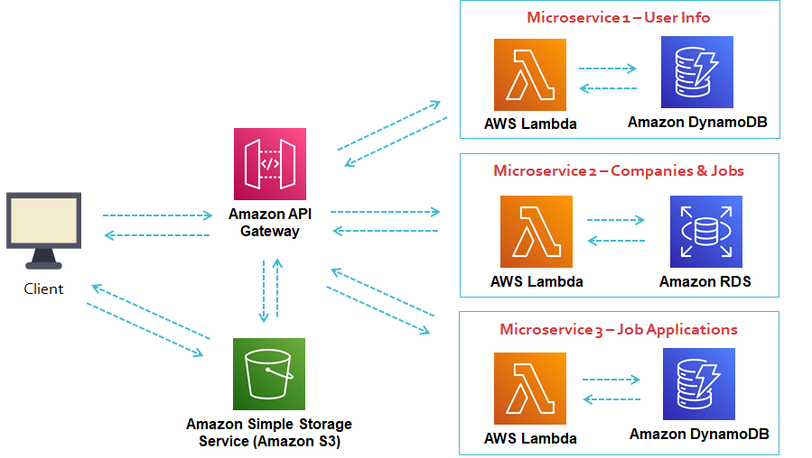

*AWS Architecture Icons:* [*https://aws.amazon.com/architecture/icons/*](https://aws.amazon.com/architecture/icons/)

# Design Screenshot

Low-fidelity design screenshots of the cloud application and navigation flows to illustrate the working of the application.

***Include navigation flows to illustrate the working of the application.***

*Suggested Tool: Figma (provide screenshots and include published link in submission)*

# Database Design Diagram

**For each microservice, specify the proposed AWS Database and provide the database design.**

* **Relational database: To provide Entity Relationship (ER) diagram and data dictionary (includes: table name, column and type, primary key, foreign key (if any)**)
* **NoSQL database: To provide data dictionary (includes: table name, column and type, partition key, sort key (if any)**)

**ER Diagram**

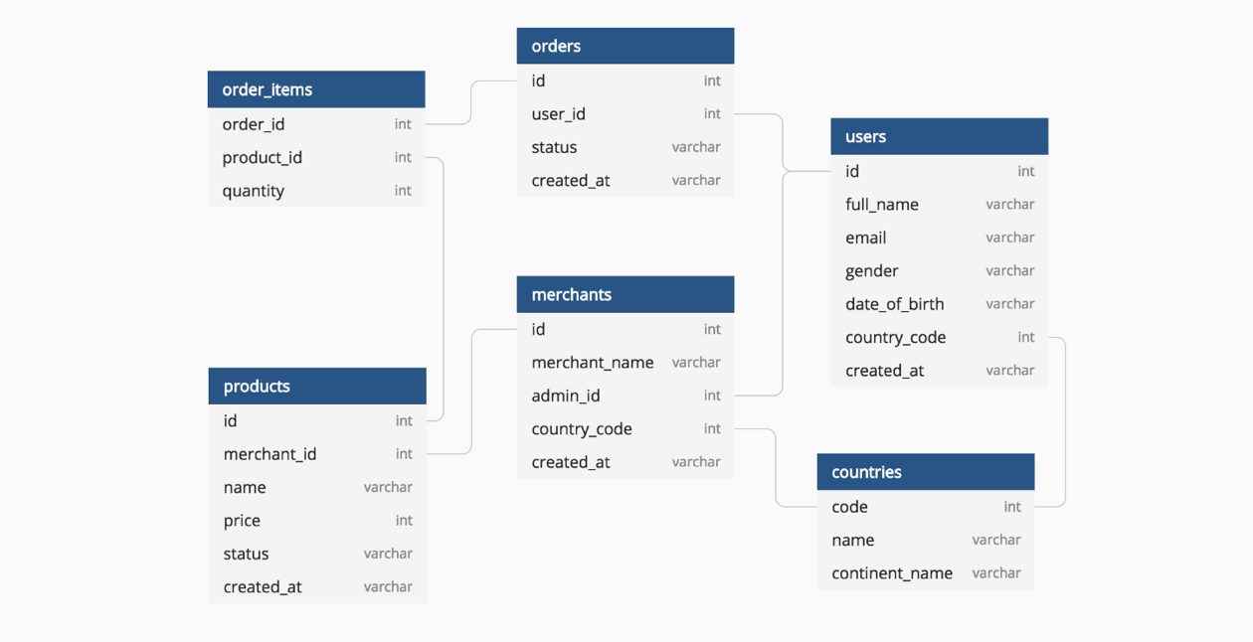

*Suggested Tool: MySQL Workbench*

**Data Dictionary (Table: Products)**

|  |  |  |  |  |  |
| --- | --- | --- | --- | --- | --- |
| **Field Name** | **Data Type** | **Field Size** | **Primary/ Foreign key**  **Partition/ Sort key** | **Description** | **Example** |
| id | Integer | 8 | Primary key | Unique number for product | 10000001 |
| Merchant_id | Integer | 8 | Foreign key | Unique number for merchant | 10000001 |
| Name | Varchar2 | 30 | - | Name of product | Laptop |
| Created at | Date/Time | - | - | Product created date | 14/09/2020  10:12:20 |
| … |  |  |  |  |  |

# API Documentation

Design and provide a set of service contracts (API definition) that define the usage of each microservices.

Example:

|  |  |  |  |
| --- | --- | --- | --- |
| **Service Name** | **HTTP method** | **Relative URI** | **Action** |
| ProductService | GET | /api/products | Get all products. |
| ProductService | POST | /api/products | Create a new product. |
| CustomerService | GET | /api/customers | Get all customers. |
| CustomerService | GET | /api/customers/{id} | Get a customer by ID. |
| …. |  |  |  |